**User Guide**

**8-Port Gigabit+8G SFP**

**Industrial Fast Ring Managed Switch**

This document applies to 8-Port Gigabit+8G SFP Industrial Managed Switch. Unless otherwise specified, 8-Port Gigabit+8G SFP is used as an example in the product diagram.

**Packing List**

When using the Switch for the first time, carefully open the packing box. The packing box should contain the following items:

* Switch \*1
* User manual \*1
* Phoenix terminal \*2
* Console Line \*1

**Note:** Precision devices are built in the device, please handle them carefully to avoid violent vibration, which may affect the performance of the device. If you find that the equipment is damaged or any parts are lost in the process of transportation, please inform us, we will give you a proper solution as soon as possible.



**Statement**

Product specifications and information mentioned in this manual are for reference only and are subject to change without prior notice. Unless otherwise agreed, this manual is for use only and does not constitute any form of warranty.

**Convention**

The product pictures in this document are for illustration only. The number and positions of ports depend on actual models. This document helps you correctly use the Switch. It describes the performance characteristics of the Switch and describes how to install the Switch. Read this manual carefully before operating the Switch.

**Directory**

[Chapter 1 Introduction To The User Guide 3](#_Toc109722149)

[1.1 Use 3](#_Toc109722150)

[1.2 User Manual Overview 3](#_Toc109722151)

[Chapter 2 Product Introduction 4](#_Toc109722152)

[2.1 Product Overview 4](#_Toc109722153)

[2.2 Product Features 4](#_Toc109722154)

[2.3 Product Advantage 5](#_Toc109722155)

[Chapter 3 Product Appearance Description 6](#_Toc109722156)

[3.1 Front Panel 6](#_Toc109722157)

[3.2 LED Indicator 7](#_Toc109722158)

[3.3 Side Plate 7](#_Toc109722159)

[Chapter 4 Installation Guide 9](#_Toc109722160)

[4.1 Installation Precautions 9](#_Toc109722161)

[4.2 Installation Environment 9](#_Toc109722162)

[4.3 Installation 10](#_Toc109722163)

[Appendix: Technical specifications 13](#_Toc109722164)

# Chapter 1 Introduction To The User Guide

Thank you for purchasing our 8-Port Gigabit+8G SFP Industrial Ring network Managed Switch! The device adopts storage and forwarding, fanless, low power consumption design, has the advantages of easy to use, compact and beautiful, simple installation, etc. The product is designed to meet Ethernet standards, with lightning protection, static protection mechanism, operating temperature range of -40°C to 75°C, stable performance, safety and reliability, can be widely used in intelligent transportation, telecommunications, security, financial securities, customs and other broadband data transmission fields.

## 1.1 Use

The purpose of this user manual is to familiarize users with and correctly use 8-Port Gigabit+8G SFP Industrial Ring network Managed Switch.

## 1.2 User Manual Overview

Chapter 1: Introduction To The User Guide.

Chapter 2: Product Introduction.

Chapter 3: Product Appearance Description.

Chapter 4: Installation Guide.

Appendix: Technical Specifications.

# Chapter 2 Product Introduction

## 2.1 Product Overview

8-Port Gigabit +8G SFP is an industrial Ring network Managed Switch developed by our company. It has 8\*10/100/1000Mbps RJ45 ports and 8\*1000Mbps SFP optical module expansion slots. Each RJ45 port supports MDI/MDIX automatic rollover and wire-speed forwarding.

The equipment support static routing functions, provide perfect security, QoS, and plenty of VLAN function has ring network function, can form a ring network, Switch between by hand in hand form a ring network topology, the redundancy, high reliability characteristics can make in a ring online link disconnected all the way, will not affect the forwarding of data on the network.

## 2.2 Product Features

* Operating temperature: -40°C ~ 75 °C;
* Low power consumption fanless, high energy aluminum alloy roof heat conduction groove shell design;
* DIN-Rail type installation;
* IEEE 802.3x full-duplex flow control and Backpressure half-duplex flow control;
* Support one-key ring network, one-key storm suppression function, with redundancy design, high reliability;
* High reliability design, supporting traditional STP/MSTP/RSTP layer 2 link protection technology;
* Support static convergence and dynamic convergence (LACP) 2 convergence modes, effectively increase the link bandwidth, improve the reliability of the link, and at the same time can achieve load balancing, link backup;
* Flexible and convenient management and maintenance Supports various management modes, such as Console, Telnet, and SSH;
* Support WEB management, simple and efficient, convenient for installation and debugging of engineering and maintenance personnel;
* Supports file upload and download management through TFTP;
* 2 power inputs, redundant backup, greatly improve product power supply reliability.

## 2.3 Product Advantage

* **-40°C ~ 75 °C operating temperature design**

-40℃~75℃ operating temperature design, selected industrial components, the use of natural heat dissipation, to ensure that the Switch can achieve long-term stable operation within the temperature range, to meet all kinds of use environment.

* **High energy aluminum alloy roof heat conduction groove shell design**

Body size 145\*109\*62mm, compact and light, full aluminum alloy high energy roof heat conduction groove shell design, better heat dissipation effect.

* **DIN-Rail installation, simple and flexible**

DIN-Rail installation design, easy and quick installation, so that users reduce unnecessary installation time, save time cost.

* **Select industrial grade components**

Chemical nickel gold PCB board, with high corrosion resistance, oxidation resistance. Select high specification capacitor, greatly improve the service life of products.

* **Supports one-click ring network and one-click storm suppression**

Supports one-click loop networks, inhibits broadcast storms, improves network reliability, and strengthens data protection. With strong environmental adaptability and high-speed topology self-healing, it can be widely used in security, monitoring and other scenarios.

* **Supports WEB management, which is simple and efficient**

Provides WEB management functions and supports basic network functions such as 802.1Q VLAN, port monitoring, and port aggregation Yes. You can manage and maintain the network through the WEB UI.

* **Supports relay alarm function**

Support system startup abnormal and power alarm function, if the system startup or input power abnormal can be timely output alarm signal.

# Chapter 3 Product Appearance Description

## 3.1 Front Panel

The front panel consists of 8\*10/100/1000Mbps adaptive RJ45 ports, 8\*1000Mbps SFP fiber module expansion slots and related indicators, as shown below:

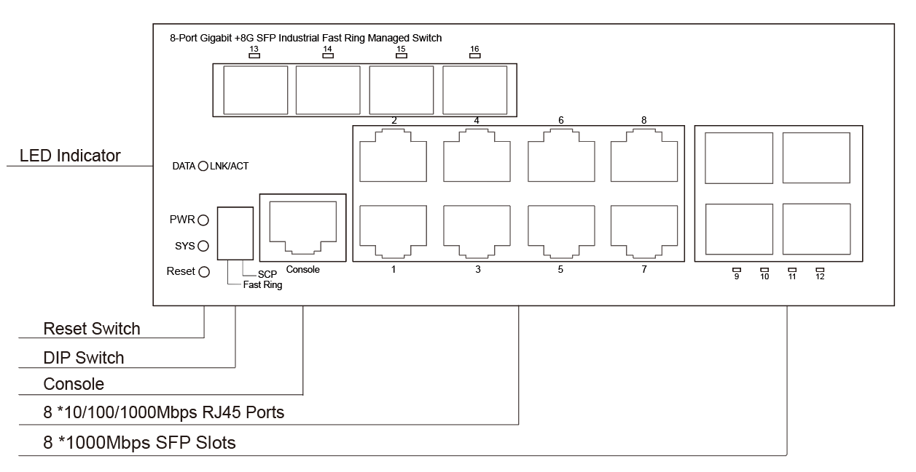Figure 3-1 Front panel of the 8-Port Gigabit +8G SFP Switch

8-Port Gigabit +8G SFP Port description:

➢**10/100/1000Mbps RJ45 Ports**

Supports 10Mbps, 100Mbps, or 1000Mbps rate adaptation, auto-MDI /MDIX, and each port has a corresponding indicator, that is, port indicators 1-8 as shown on the panel in the figure above.

➢**1000Mbps SFP Slots**

SFP slots are independent SFP slots located on the right and upper part of the panel. Each port has a corresponding indicator, as shown in the figure 9-16.

➢ **Console Port**

The Console port is used to connect to the serial port of a computer or other terminal device and manage or configure Switches.

➢**SCP**

One-touch broadcast storm suppression: limits broadcast packets, unicast packets, and multicast packets to a certain rate.

➢**Fast Ring**

To enable the ERPS function, set the last 2 SFP slots as the sub-network ports of the ring network.

## 3.2 LED Indicator

The LED indicators of the Switch are shown in the following table. Users can monitor the work and running status of the Switch conveniently and quickly through the following indicators:

|  |  |  |
| --- | --- | --- |
| LED | Color | Function |
| PWR | Green | Off: No Power supply.  Light: Indicates the Switch has power. |
| DATA | Green | Off: No device is connected to the corresponding port.  Light: Indicates the link through that port is successfully  established at 10/100/1000Mbps.  Blink: Indicates that the Switch is actively sending or  receiving data over that port. |
| SYS | Green | Blinking: The system is working properly  Off: The system is being started or is abnormal |

## D:\Backup\Documents\WXWork\1688856257300203\Cache\Image\2022-06\企业微信截图_1655452922172.png3.3 Side Plate

Figure 3-2 Side panel of the 8-Port Gigabit+8G SFP Switch

The side panel of the Switch provides 5-position industrial wiring terminals and power input DC: The standard voltage is 12V to 55V, and the input voltage of the 2 PWR1 and PWR2 power supplies is 12V to 55V. The DC power input of the Switch is redundant. The 2 PWR1 and PWR2 power supplies can be used individually or connected to 2 independent DC power supply systems. When any power supply system fails, the device can run normally without interruption, which improves the reliability of network operation.

**Relay port:** Alarm port, support machine abnormal alarm function. This interface needs to be connected to an external alarm device. When the machine starts abnormally or when the power is on, the internal relay will close and output the alarm signal in time, which has the function of automatic alarm, safety protection and isolation conversion in the circuit.

# Chapter 4 Installation Guide

This chapter helps users correctly install and safely use Switches.

## 4.1 Installation Precautions

 **Precautions:** To avoid equipment damage and personal injury, observe the following precautions:

* The Switch room should be dry and ventilated, free from corrosive gases and strong electromagnetic interference.
* The humidity of the Switch equipment room should be 5% to 95%. Install proper equipment if possible.
* The grounding of the Switch shall comply with the grounding requirements described in this manual, and shall be separately and well grounded.
* Keep a proper distance between the Switch and other devices. Do not stack other devices with the Switch.
* The connection cable between the Switch and the distribution frame should be standardized and reasonable, and the distribution frame (box) jumper wire should be concise and clear to prevent the phenomenon of parallel lines and wires.
* To reduce the risk of electric shock, do not open the shell of the Switch when it is working. Do not open the shell of the Switch even when it is not powered on.

 **Safety Tips:**

* Ensure that the PGND cable of the power socket is properly grounded.
* Ensure sufficient space for heat dissipation and ventilation of the Switch. Do not place heavy objects on the Switch.

## 4.2 Installation Environment

Before installation, make sure that the proper working environment is available, including power requirements, adequate space, proximity to other equipment to be connected, and other equipment in place. Please confirm the following installation requirements:

* Ensure the stability of the workbench and good grounding;
* Check whether cables and connectors required for installation are in place (less than 100m).
* The product does not provide installation components. Prepare components of the selected installation type, such as screws, nuts, and tools, to ensure reliable installation.
* Power supply: 12V to 55V dc power supply.
* Environment: operating temperature: -40°C to 75 °C relative humidity: 5% to 95%.

## 4.3 Installation

**Rail mounting**

The 45mm standard DIN-Rail installation is very convenient for most industrial applications. The installation steps are as follows:

* Check whether the installation accessories of DIN-Rail guide tools are available (installation accessories are provided for this product);
* Check whether DIN-Rail is firmly fixed, whether there is a suitable place to install the product;
* Clamp the lower part of the DIN-Rail connecting seat of the product accessories into the DIN-Rail (lower part with spring support), and then clamp the upper part of the connecting seat into the DIN-Rail (lower part clamp a little, slightly force to keep the balance of the equipment stuck into the upper part).

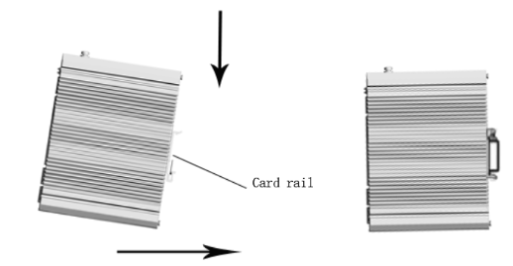

Figure 4-1 Schematic diagram of industrial machine guide rail installation

 **Note:** Aluminum alloy DIN-Rail hooks have been fixed to the rear panel of the Switch.

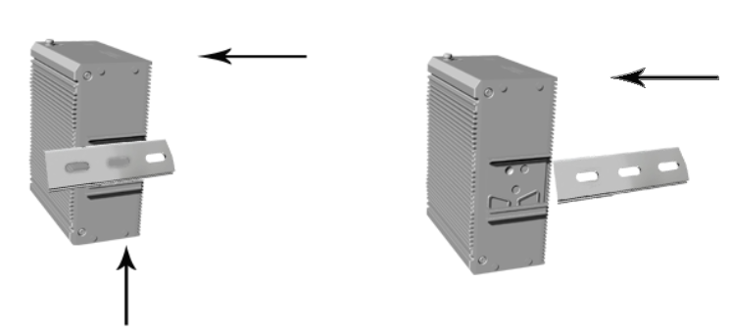

Figure 4-2 Schematic diagram of industrial machine guide rail disassembly

 **Power on**

* Power on: First insert the power terminal of the power cable into the power port of the device, then plug in the power plug and power on. After the Switch is started, the Switch automatically initializes. If all port indicators are on and then off, the system is successfully reset, and the power LED indicator is always on.
* Power off operation: Unplug the power plug first, and then remove the wiring part of the terminal. Please pay attention to the above operation sequence.

**Wall mounted Installation**

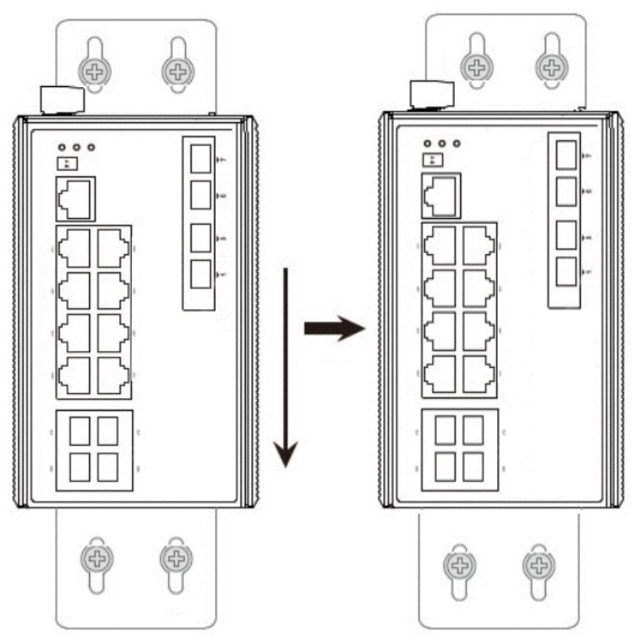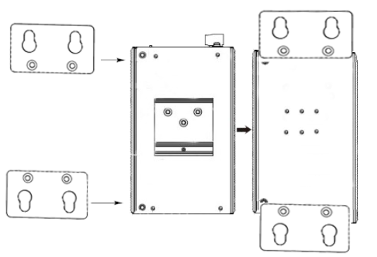The following describes how to install a Switch on the wall:

Schematic diagram of wall mounted installation of industrial machine

* Remove the DIN-Rail mounting plate on the rear board of the Switch.
* Install the wall mounting board on the Switch as shown below.
* Four wall screws are required to mount the Switch on the wall, as shown in the figure above.
* When fixing the screws to the wall, do not screw the screws into the wall completely. Leave a space of about 2 mm for sliding the wall panel between the wall and the screws.
* After securing the screws to the wall, place the four screw heads through most of the keyhole, then place the Switch vertically and tighten the screws to increase stability.

# Appendix: Technical Specifications

|  |  |
| --- | --- |
| Model | 8-Port Gigabit +8G SFP Industrial Fast Ring Managed Switch |
| Standard | IEEE 802.3, IEEE 802.3u, IEEE 802.3ab, IEEE 802.3z, IEEE 802.3x,  IEEE 802.1X, IEEE 802.1q, IEEE 802.1p, IEEE 802.1d, IEEE 802.1w,  IEEE 802.3ad |
| Network ­Media(Cable) | 10BASE-T: UTP category 3, 4, 5 cable(≤100m)  100BASE-TX: UTP category 5, 5e cable(≤100m)  1000BASE-T: UTP category 5e, 5 cable(≤100m)  1000BASE-X: MMF, SMF |
| MAC Address Table | 8K, Auto-learning, Auto-updating |
| Jumbo Frame | 9216Bytes |
| Transfer Mode | Store-and-Forward |
| Packet Buffer | 4.1M bit |
| Packet Forward Speed | 23.8Mpps |
| Input Power Supply | DC:12-55V |
| Switching Capacity | 20Gbps |
| Dimensions (L\*W\*H) | 145\*109\*62mm |
| Fan | Fanless |
| Temperature | Operating Temperature: -40°C ~ 75 °C (-40 °F ~167°F )  Storage Temperature: -40 °C ~ 80°C (-40 °F ~176°F ) |
| Humidity | Operating Humidity: 5% ~ 95% non-condensing  Storage Humidity: 0% ~ 95% non-condensing |
| MTBE | >100000hours |