|  |  |
| --- | --- |
| **Micro-spectrophotometer** | **Nanobio-400** |

**Features**

* Ultra-micro nucleic acid analyzer with fixed wavelength (260 nm, 280 nm,365 nm).
* Android system, 7-inch capacitive touch screen, no computer connection required.
* LED light source, long life component.
* lt is mainly used to detect the concentration and purity of nucleic acid, and to detect the concentration of nucleic acid at 260 nm, the concentration of protein at 280 nm. The 260 / 280 ratio is used to measure the purity.
* Newly designed OD600 optical path detection system, new cuvette mode,convenient for the concentration detection of bacteria, microorganisms and other culture solutions.
* The test data is transferred to the computer via USB for easy sorting and analysis.
* The built-in printer can print the report directly.

**Application**

* 260 nm:dsDNA、ssDNA、RNA
* 280 nm:A280、BSA、lgG、 Lysozyme
* 562 nm: BCA
* 595 nm: Bradford
* 600 nm: Bacterial concentration
* 650 nm: Lowry

**Description**

Micro-specrophotometer can quickly and accurately detect nucleic acid, protein and cell solution. Because it is easy to use, less sample consumption, no preheating, can quickly cleanup residual samples, no cuvettes or other sample positioning devices required, samples do not need to be diluted and other characteristics. It has become a routine instrument in many laboratories.

Nanobio-400 ultra-micro nucleic acid analyzer is an instrument used to detect the concentration and purity of DNA and RNA. The sample size required for each measurement is only 1.0 to 2**μ**L.User can directly add the sample point to the sample plate without accessories such as cuvettes or capillaries.

|  |  |
| --- | --- |
| **Model** | **Feature** |
| Nanobio-400 | Fixed wavelength, LED light source, OD600 optical path detection system |

ATP9100

ATP9100F（谱图所对应区域显示）

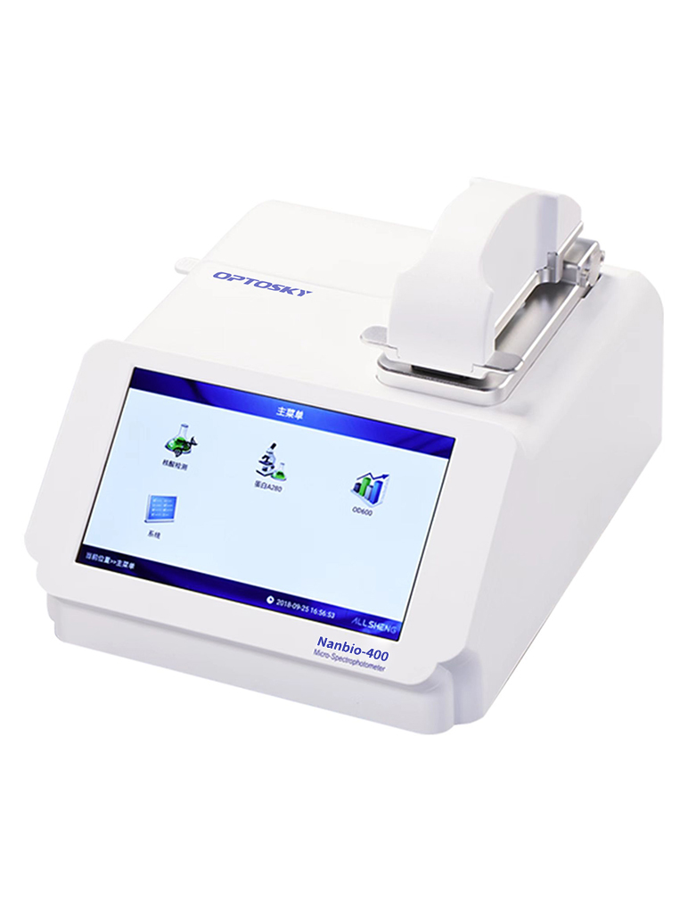

# 1.Performance

**Nanobio-300** **Nanobio-400** **Nanobio-500**

|  |  |  |  |
| --- | --- | --- | --- |
| Wavelength range | 200~800 nm | 260 nm, 280 nm | 200~800 nm |
| Minimum sample size | 0.5~2.0 μL | 1.0~2.0 μL | 0.5~2.0 μL |
| Path length | 0.2 mm  1.0 mm | 0.5 mm | 0.05 / 0.2 mm  1.0 mm |
| Light source | Xenon flash lamp | UV LED | Xenon flash lamp |
| Detector type | 2048-linear CCD array | UV-silicon photocell | 2048-linear CCD array |
| Wavelength accuracy | 1 nm | ---- | 1 nm |
| Spectral resolution | ≤ 3 nm | ≤ 8 nm | ≤3 nm |
| Absorbance precision | 0.003 Abs | 0.005 Abs | 0.003 Abs |
| Absorbance accuracy | 1 % (7.332 Abs at 260 nm) | 2 % (7.332 Abs at 260 nm) | 1 % (7.332 Abs at 260 nm) |
| Absorbance range | 0.04~90 A | 0.2~50 A | 0.04~300 A |
| Nucleic acid detection range | 2~4500 ng/μL (dsDNA) | 10~2500 ng/μL (dsDNA) | 2~15000 ng/μL (dsDNA) |
| Measurement time | < 5 s | < 6 s | < 6 s |
| Dimension (W×D×H) mm | 210×268×181 | 208×280×186 | 208×320×186 |
| Weight | 2.8 kg | 2.0 kg | 3.6 kg |
| Sample pedestal material | Aluminum alloy and quartz fiber | Aluminum alloy and quartz fiber | Aluminum alloy and quartz fiber |
| Operating voltage | DC 24 V 2 A | DC 24 V 2 A | DC 24 V 2 A |
| Operating power | 25 W | 25 W | 25 W |
| Standby power | 5 W | 5 W | 5 W |
| Software compatibility | Android system | Android system | Android system |

|  |  |  |  |
| --- | --- | --- | --- |
| Wavelength range | 200~800 nm | 200~800 nm | 260 nm, 280 nm |
| Nucleic acid test dsDNA (ng/μL) | 2~4500 | 2~15000 | 10~2500 |
| A280 protein BSA (mg/mL) | 0.1~135 | 0.1~450 | 0.5~75 |
| Colorimetry |  |  |  |
| Full wavelength scan |  |  |  |
| OD600 |  |  |  |
| Fluorometer |  |  |  |
| Touch screen |  |  |  |

**Selection guide Nanobio-300 Nanobio-400 Nanobio-500**