Confocal Raman Microscope | ATR8800
Description:
The ATR8800 series scientific-grade confocal Raman imaging microscope. This is a true confocal Raman imaging microscope self-developed successfully first-launched in China market in 2022. It provides wavelengths of 266 nm, 325 nm, 514 nm, 532 nm, 638 nm, 785 nm, 830 nm, 1064 nm for free selection solutions, one-band, dual-band, triple-band, or quadri-band to satisfy customers requirements. With confocal pinhole can improve spatial resolution with a minimum spot size up to 1.6μm, and result in trace material identification.
Auto-focus and Auto-scan Raman imaging microscope features super sensitivity, super fast scan, and excellent resolution of 0.5cm-1.
Confocal Raman microscopy can combine Raman spectroscopy with microscopy technique to measure trace micron sample less than 2 seconds.
The unique seal sample compartment is an ideal for any experiment on the daytime, push and pull seal door can start measurement w/o turning off light in the lab.
The free software provides a powerful function of multiple band splicing large area imaging data.
Features：
- Auto-imaging, auto-focus and auto-scan.
- Large imaging (50x50mm), auto image splicing.
- Max. 4 wavelengths build in one system
- Rotating turret grating
- Seal door design fit to day and night test
- Long focal length & super high-resolution
- Confocal Imaging large area
- Super sensitivity, SNR > 6000:1.
- The maximum integration time reach up to1.3 hours.
- True confocal for accurate Raman images.
- Super spatial resolution.
- Exclusive software for switching optical path.
- Fast positioning and finding the focus
- Good quality objective lens, spot size up to micron.
- 5-mega cameras with clear and accurate images
- USB 3.0 connector to the computer.
Application：
- Nanoparticles and new materials.
- Research institute research.
- Biological sciences.
- Forensic expertise.
- Materials science.
- Medical immune analysis.
- Agricultural and food identification.
- Gemstones and inorganic mineral identification
- Environmental science

Fig 1

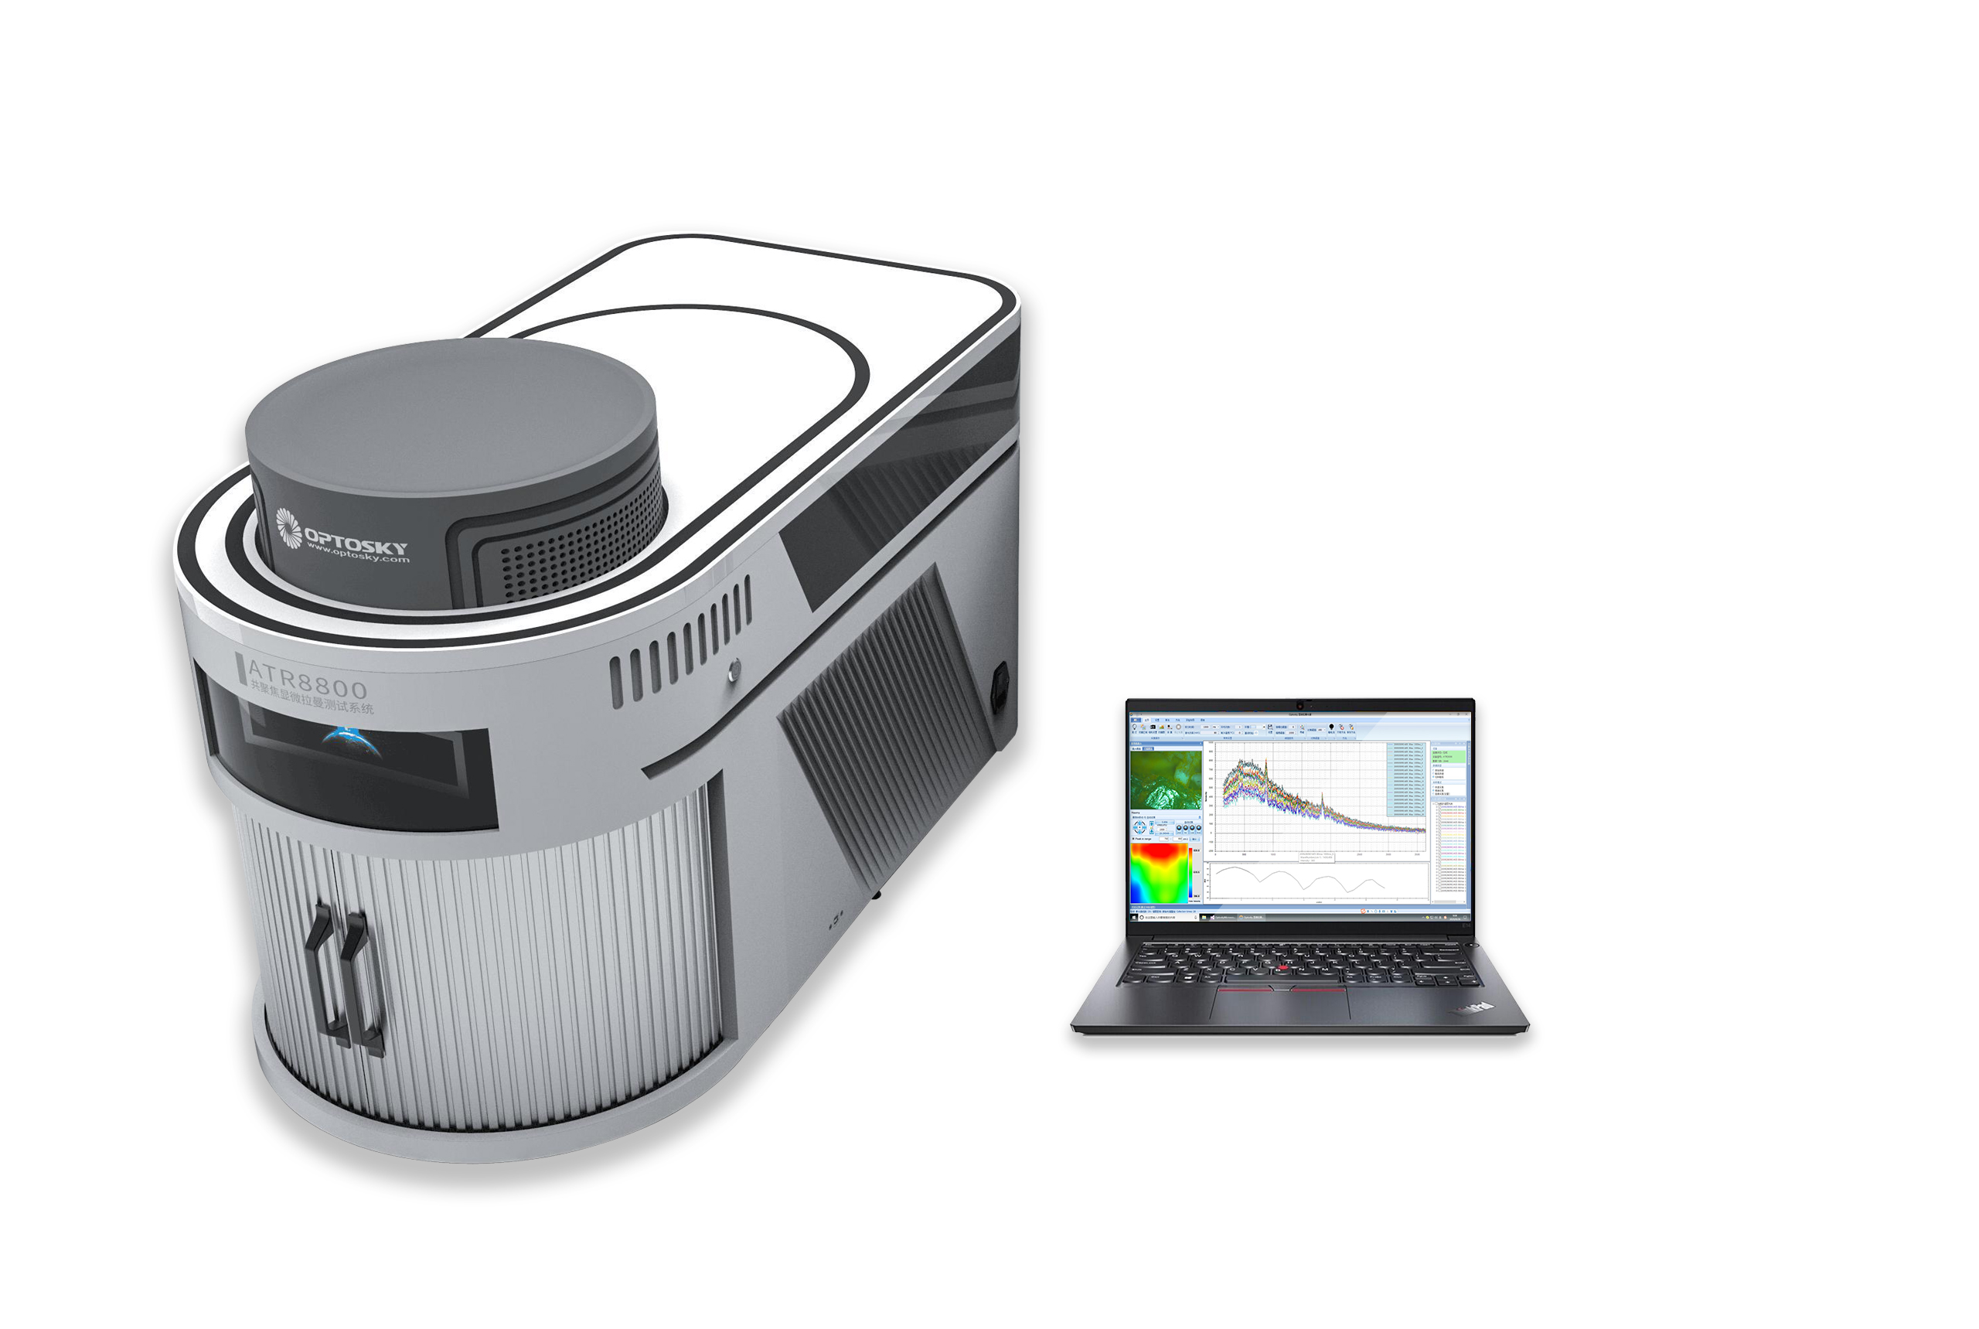

Table 1 ATR8800 product selection table
Model | Focus length | Wavelength /nm^{*3} | Laser power /mW | Range^{*1*2} | Resolution/cm^{-1*4}
ATR8800-FL350 | 350mm | 266 | 50 | 50~ 10000 | 4.5
 |  | 325 | 30 | 50~ 10000 | 2.6
 |  | 532 | 100 | 5 ~ 10000 | 1.4
 |  | 638 | 80 | 5~ 10000 | 1.4
 |  | 785 | 350 | 5~ 10000 | 2.1
 |  | 1064 | 500 | 50~ 10000 | 5.2
ATR8800-FL510 | 510mm | 266 | 50 | 50~ 10000 | 2.9
 |  | 325 | 30 | 50 ~ 10000 | 1.9
 |  | 532 | 100 | 5~ 10000 | 0.9
 |  | 638 | 80 | 5 ~ 10000 | 0.9
 |  | 785 | 350 | 5 ~ 10000 | 1.4
 |  | 1064 | 500 | 50~ 10000 | 3.6
ATR8800-FL810 | 810mm | 266 | 50 | 50~ 10000 | 2.2
 |  | 325 | 30 | 50 ~ 10000 | 1.1
 |  | 532 | 100 | 5 ~ 10000 | 0.45
 |  | 638 | 80 | 5 ~ 10000 | 0.45
 |  | 785 | 350 | 5 ~ 10000 | 0.86
 |  | 1064 | 500 | 5~ 10000 | 2.3
ATR8800LT：Deep cooling to -30℃, long integration time (up to 1.3h)
ATR8800EM: Deep Cooled Area Array EMCCD Detector
ATR8800BS: Basic series
ATR8800AF: Auto-focus
ATR8800MP: Scan imaging-Mapping, Auto-focus
ATR8800UV: UV-enhanced Mapping
Note:
*1: Max. wavenumber range decided by different wavelengths;
*2: Standard started from 150cm⁻¹, the beginning wavenumber can be lowered down to 5cm⁻¹, 50cm⁻¹;
*3: Optional wavelengths customized;
*4: Best resolution can be further improved by reducing slit size;
*5: Table above listed include standard models, and Optosky accept optional wavelengths or range as required.

Ordering Guide:
Naming example:
- ATR8800AF-LT-FL350-532+638: Autofocus, long integration time, focal length of 350mm, excitation wavelengths are dual wavelengths: 532nm and 633nm respectively
- ATR8800MP-EM-FL810-532+638+1064: Scanning imaging, EMCCD detector, focal length is 810mm, excitation wavelength is three wavelengths: 532nm, 633nm and 1064nm respectively

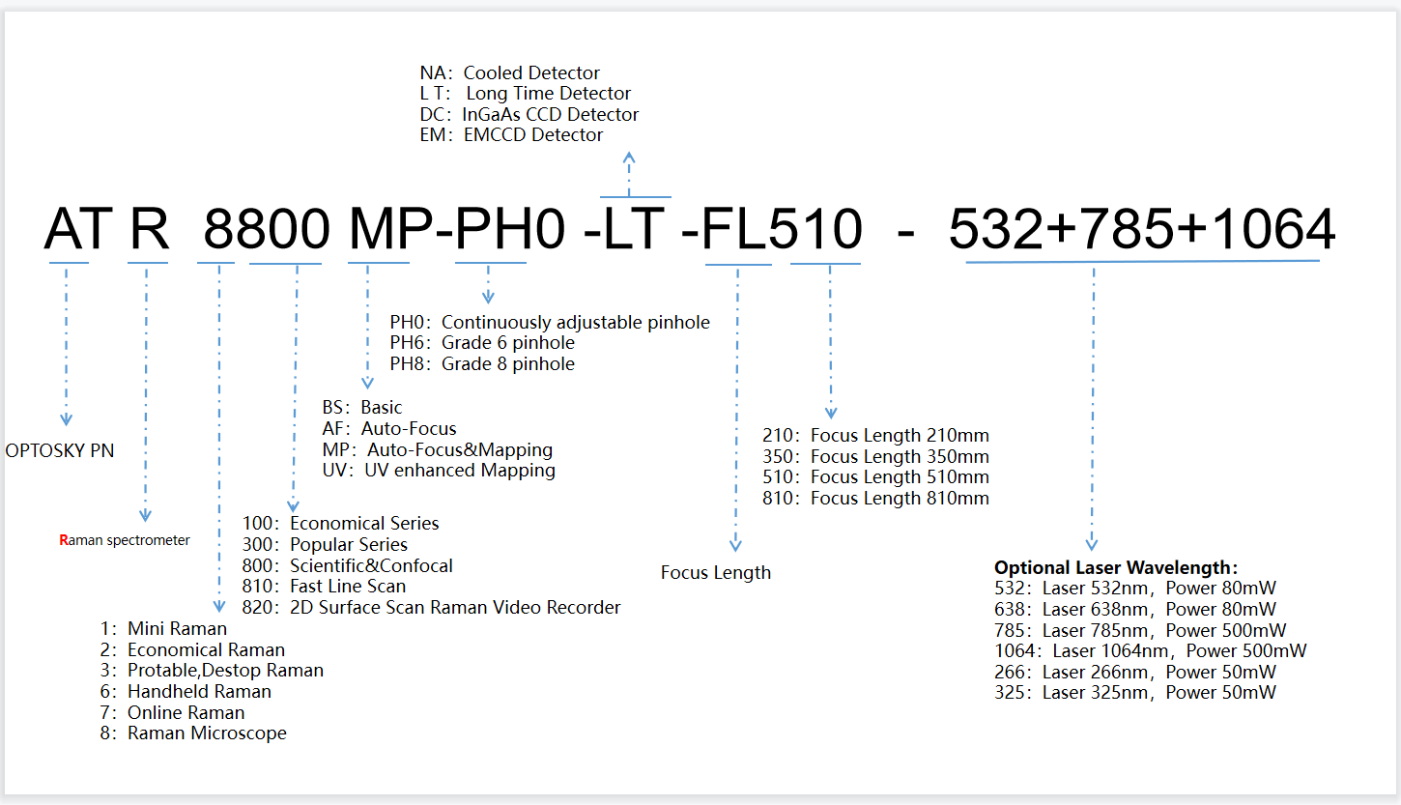
ATR8800 performance parameters
Excitation wavelength | 266, 325, 532, 638, 785, 1064nm optional, simultaneous integration of up to 4 excitation wavelengths
Laser power | 266nm：30 mW  325nm: 30mW  532nm：100mW  633nm：80mW  638nm：80mW  785nm：350mW  1064nm：500mW
Optical path | C-T optical path
Focal length | 350mm,510mm,810mm Optional
Built-in grating | Standard 3 pieces; 300 lines, 600 lines, 1200 lines, 1800 lines, 2400 lines optional
Detector | 1) Deep cooling area array CCD: 2000X256 pixels  2) Deep cooling and high sensitivity EMCCD: 1600X200 pixels  3) Deep cooling area array InGaAs CCD: 512X1 pixels  Up to 2 detectors can be integrated, choose one of detector 1# and detector 2#;
Objectives | Standard configuration：4X,10X,20X,50X；  Optional configuration：100X
Microscopic lighting | High brightness long life white light LED
Lighting Type | Epi Illuminiation
Microscope camera | 5-mega pixels industrial camera
Focusing method | Confocal Raman Imaging
Laser spot diameter | >1μm
Laser stability | σ/μ <±0.2%
Interface | USB3.0
X, Y axis two-dimensional platform
Move method | Manual/Electric optional
Moving range | 50 X 50 mm,100X100mm optional
Mobile resolution | 0.1 μm
Positioning accuracy | 1 μm
Scan interval | Software setting, min. 1μm
Scan speed | 20 mm/s
Nano stage (optional) | Minimum displacement resolution 2nm, displacement accuracy 10nm
Z axis (auto focus)
Focus accuracy | ≤ ±0.2 μm
Maximum stroke | 20 mm
Focus speed | < 10 s
Nano stage (optional) | Minimum displacement resolution 2nm, displacement accuracy 10nm
Physical parameter
Dimensions | ATR8800-FL350：905(L)×58.3(W)×643(H)  ATR8800-FL510：1009(L)×58.3(W)×643(H)  ATR8800-FL810：1520(L)×68.3(W)×643(H)
Weight | ATR8800-FL350：59 Kg  ATR8800-FL510：63 Kg  ATR8800-FL810：78 Kg
Working environment parameters
Voltage | 100~240 VAC
Peak power | < 200 W
Other motivation | NA
Emission | NA
Platform requirements | Air Floating Vibration Isolation Optical Platform
Working temperature and humidity | Constant temperature (25±2℃), constant humidity (50±10%)
Cleanliness | Above ten thousand
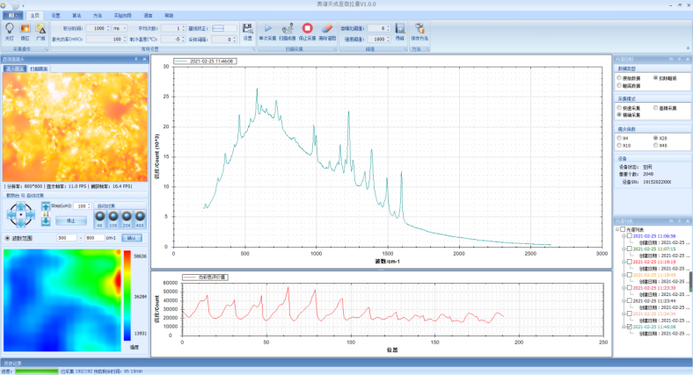
Fig .1 Software interface of ATR8800
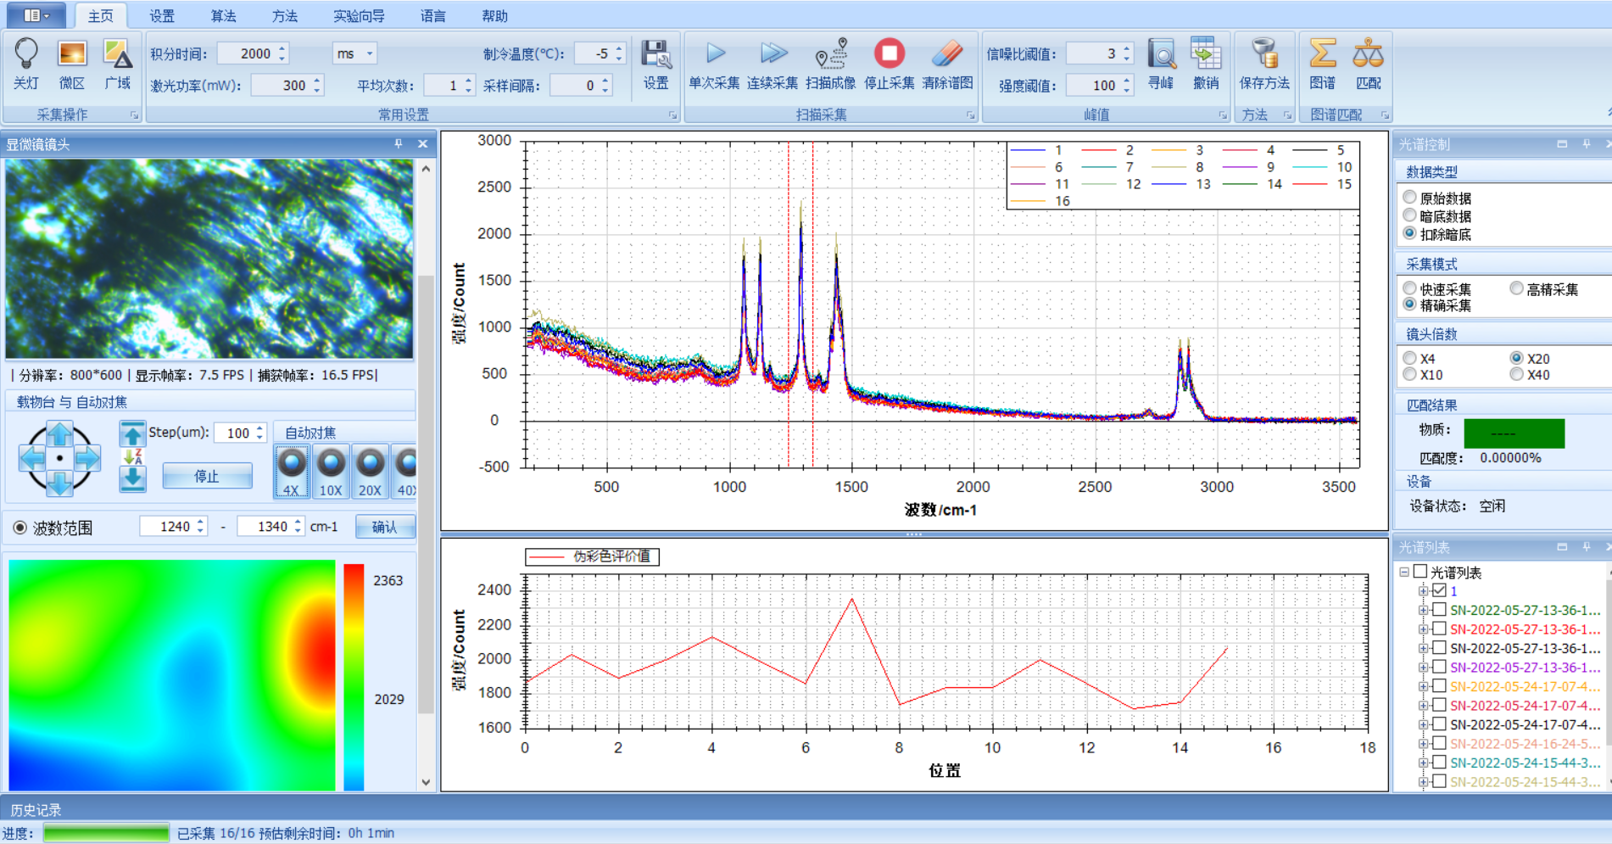
Fig .2 Software interface of ATR8800
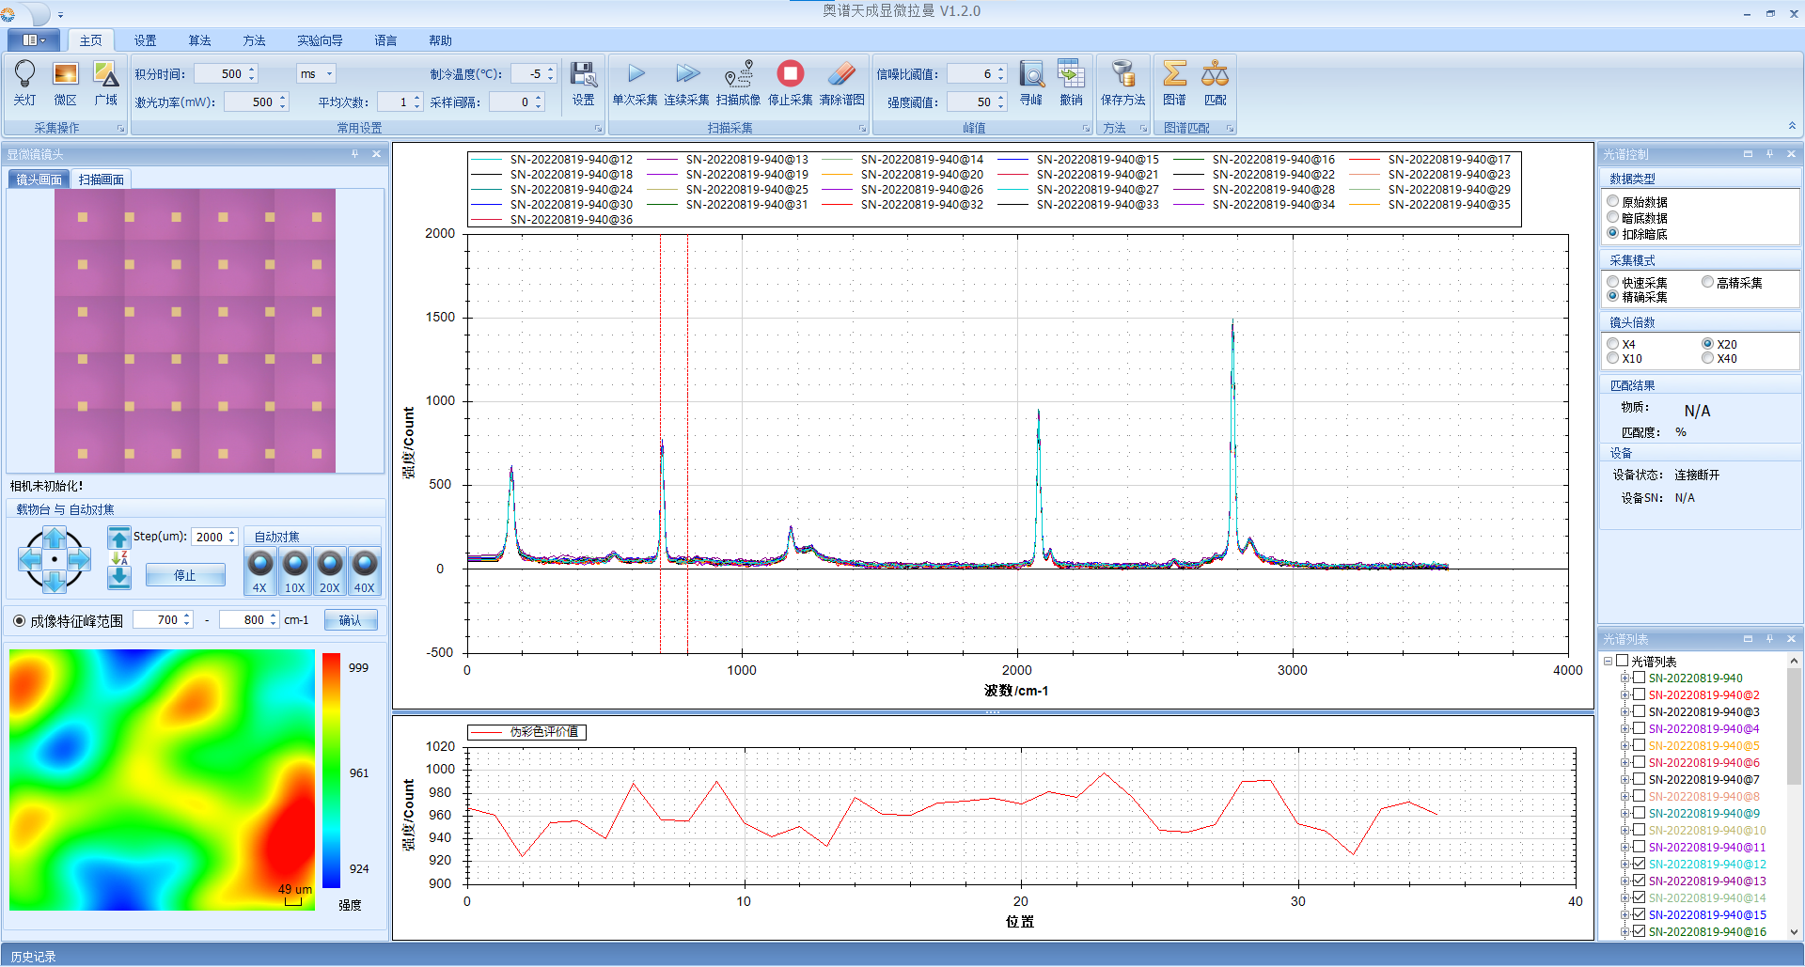 Fig .3
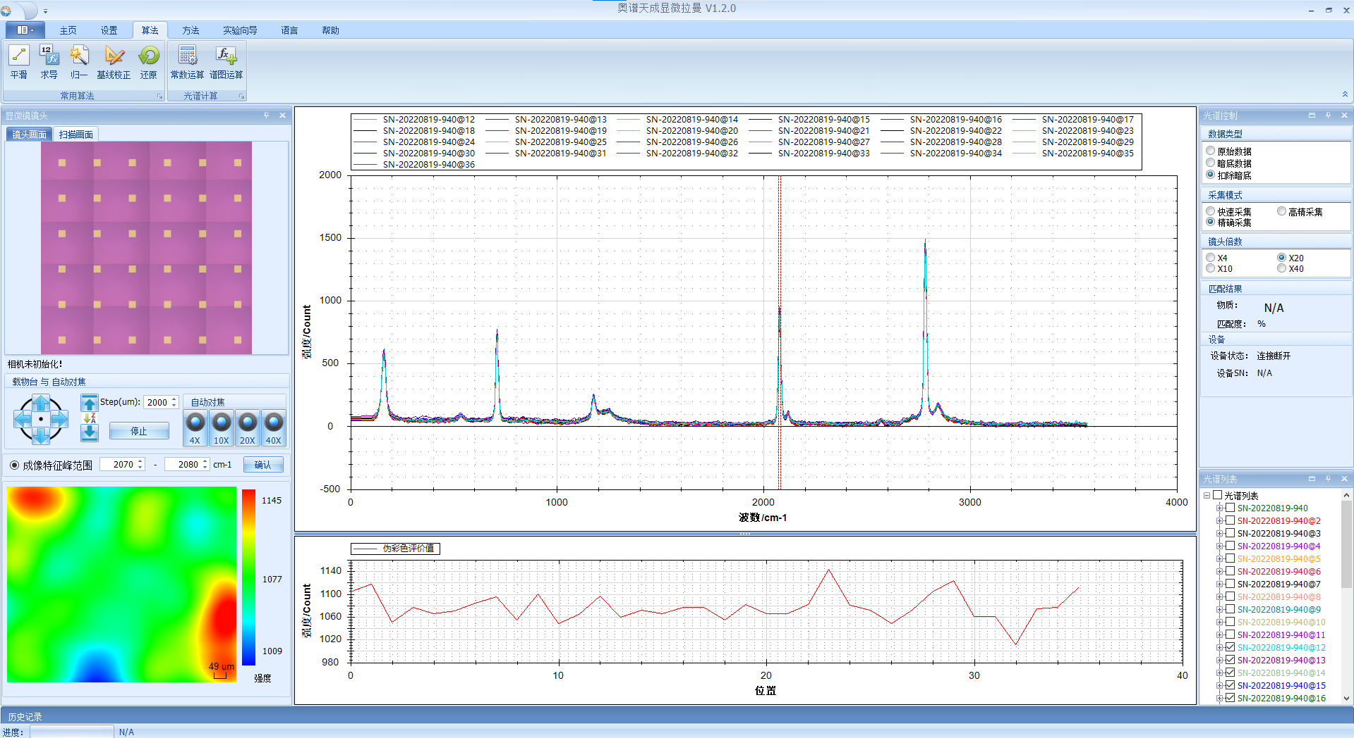
Fig .4

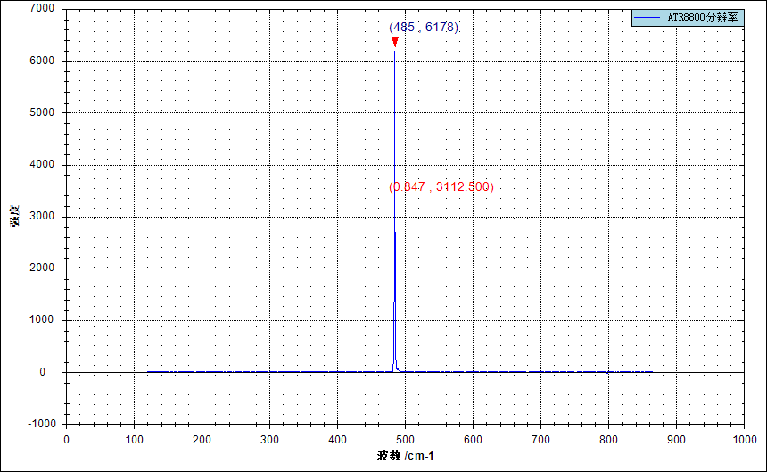
Fig .5 The test results indicate: the resolution of the instrument reaches 0.847 cm-1, the test specification: according to the national standard "General Specification for Raman Spectrometer", the test equipment: ATR8800-FL510, the test light source: mercury-argon lamp, the collection line: 546.08nm

